

|  |
| --- |
| JCU |
| CP3405 Assessment |
| Jarod Hine, Siddharth Parmar, Chengcheng Xiong, Peng Cheng |
| 11-1-2019 |

**Table of Contents**

***Introduction*** ***4***

***Velocity Chart*** ***4***

**Introduction** **4**

**Story Point Assigning** **4**

**Averaging the Velocity Based on Past Sprint Track Record** **4**

**Velocity Chart** **5**

**Demonstration** **5**

***Burn-down Charts*** ***5***

**Introduction** **5**

**First Burn-down Chart** **5**

Step 1 – Create Estimate Effort 5

Step 2 – Track Daily Process 5

Step 3 – Compute the Actual Effort 6

Step 4 – Obtain the Final Dataset 6

Step 5 – Plot the Burndown using the Dataset 6

Demonstration 6

**Second Burn-down Chart** **6**

Step 1 – Create Estimate Effort 6

Step 2 – Track Daily Process 7

Step 3 – Compute the Actual Effort 7

Step 4 – Obtain the Final Dataset 7

Step 5 – Plot the Burndown using the Dataset 7

Demonstration 7

**Third Burn-down Chart** **8**

Step 1 – Create Estimate Effort 8

Step 2 – Track Daily Process 8

Step 3 – Compute the Actual Effort 8

Step 4 – Obtain the Final Dataset 8

Step 5 – Plot the Burndown using the Dataset 8

Demonstration 9

***Product Backlog and Sprint Backlogs*** ***9***

**Product Backlog** **9**

**First Sprint Backlog** **9**

**Second Sprint Backlog** **9**

**Third Sprint Backlog** **10**

***Scrum Boards*** ***10***

**Introduction** **10**

**Scrum Board** **11**

***Daily Scrum Meeting*** ***12***

**Introduction** **12**

Team Members Introduction 12

**Stand-ups Meeting Record for Sprint 1** **12**

**Stand-ups Meeting Record for Sprint 2** **14**

**Stand-ups Meeting Record for Sprint 3** **16**

***Sprint Demos*** ***18***

**Introduction** **18**

**Sprint 1 Demo** **18**

Sprint 2 Demo 18

Sprint 3 Demo 18

***Sprint Retrospectives*** ***19***

**Introduction** **19**

**Sprint 1 Retrospective** **19**

What went well in the Sprint? 19

What went wrong in the Sprint? 19

What we had to Learn in the Sprint? 20

What should we do differently in the next Sprint? 20

**Sprint 2 Retrospective** **21**

What went well in the Sprint? 21

What went wrong in the Sprint? 22

What we had to Learn in the Sprint? 23

What should we do differently in the next Sprint? 23

**Sprint 3 Retrospective** **23**

What went well in the Sprint? 23

What went wrong in the Sprint? 24

What did we learn in the Sprint? 24

What should we do differently in the next Sprint? 25

***Product Increments*** ***26***

**First Increment:** **26**

**Second Increment:** **26**

**Third Increment:** **27**

**Conclusion** **28**

# Introduction

The report is composed by Jarod Hine, Siddharth Parmar, Chengcheng Xiong, Peng Cheng. The main purpose of the report is to present how Scrums were conducted through 3 sprints during this semester. JCU Career Link is our project to provide a communications platform in a regional area to promote job opportunities. The challenge of this is accommodating and integrating the different set of services required for the 3 distinct types of users, students, professors and employers.

# Velocity Chart

## Introduction

Velocity Chart is an indication of the average amount of Product Backlog turned into an Increment of product during a Sprint by our team. Our Development Team tracked Velocity chart to fulfil their achievement.

## Story Point Assigning

|  |  |  |  |  |  |
| --- | --- | --- | --- | --- | --- |
| Story Point | 1 | 3 | 6 | 7 | 12 |
| User Story for “done” |
| Sprint 1 | Landing Page |  | Login | CSS for 1st Sprint | Registration |
|  |  |  | Login Failed |  |
| Sprint 2 |  |  | Convert CSS to bootstrap | Email login | Website styling |
|  | Home page |  | User account types |  |
| Sprint 3 | Email login | User Profile | Registration | Body Template | Job-listing and Listing |
| Profile Page |  | Search page | 3 user account types |  |

## Averaging the Velocity Based on Past Sprint Track Record

|  |  |  |  |  |  |  |
| --- | --- | --- | --- | --- | --- | --- |
| Sprint order | Sprint 1 | | Sprint 2 | | Sprint 3 | |
| Story Points | 1 | 7 | 7 | 7 | 1 | 3 |
| 12 | 6 | 3 | 12 | 7 | 6 |
| 7 |  | 6 |  | 12 | 7 |
| Total | 33 | | 35 | | 36 | |

## Velocity Chart

## Demonstration

We used the Fibonacci Sequence to measure story point. For each Sprint, we gave each task a story point and sum them at the end. In our project, we use Velocity Chart to track our progress of each definition of done, as well as the progress for all Sprint. From the Velocity Chart above, we can easily draw a conclusion, through Sprint 1 to Sprint 3, the difficulty of our integration is increasing.

# Burn-down Charts

## Introduction

The Burn-down Chart is a measurement tool that shows the completed work per day against the projected rate of completion for the current project release. CCJS use Burn-down Charts monitoring the project scope creep Keeping the team running on schedule Comparing the planned work against the team progression.

## First Burn-down Chart

#### Step 1 – Create Estimate Effort

|  |  |  |  |  |  |  |
| --- | --- | --- | --- | --- | --- | --- |
|  | Day 0 | Day 2 | Day 4 | Day 6 | Day 8 | Day 10 |
| Effort Remaining | 50 | 40 | 30 | 20 | 10 | 0 |

#### Step 2 – Track Daily Process

|  |  |  |  |  |  |  |  |
| --- | --- | --- | --- | --- | --- | --- | --- |
| Task | Hours | Day 2 | Day 4 | Day 6 | Day 8 | Day 10 | Total |
| Landing Page | 5 | 1 | 1 | 1 | 1 | 1 | 5 |
| Registration | 5 | 1 | 1 | 0 | 1 | 2 | 5 |
| Login | 5 | 1 | 1 | 1 | 0 | 2 | 5 |
| Login Failed | 5 | 2 | 1 | 0 | 1 | 1 | 5 |
| CSS for 1st Sprint | 5 | 2 | 1 | 1 | 0 | 1 | 5 |

#### Step 3 – Compute the Actual Effort

#### Step 4 – Obtain the Final Dataset

|  |  |  |  |  |  |  |
| --- | --- | --- | --- | --- | --- | --- |
|  | Total | Day 2 | Day 4 | Day 6 | Day 8 | Day 10 |
| Actual Effort | 50 | 36 | 26 | 20 | 14 | 0 |
| Effort Remaining | 50 | 40 | 30 | 20 | 10 | 0 |

#### Step 5 – Plot the Burndown using the Dataset

### Demonstration

For the first Sprint, we group started the basic programming using Django to create a simple website including several main pages. The task assigned to members is simple and equally. There is no time sequence for each part. Thus we can finish it on time.

## Second Burn-down Chart

#### Step 1 – Create Estimate Effort

|  |  |  |  |  |  |  |
| --- | --- | --- | --- | --- | --- | --- |
|  | Day 0 | Day 2 | Day 4 | Day 6 | Day 8 | Day 10 |
| Effort Remaining | 50 | 40 | 30 | 20 | 10 | 0 |

#### Step 2 – Track Daily Process

|  |  |  |  |  |  |  |  |
| --- | --- | --- | --- | --- | --- | --- | --- |
| Task | Hours | Day 2 | Day 4 | Day 6 | Day 8 | Day 10 | Total |
| User account types | 5 | 1 | 1 | 1 | 1 | 1 | 5 |
| Home page | 5 | 1 | 1 | 1 | 1 | 1 | 5 |
| Footer Bar | 5 | 1 | 1 | 1 | 1 | 1 | 5 |
| Menu Bar | 2 | 0 | 1 | 1 | 0 | 1 | 2 |
| Convert CSS to bootstrap | 3 | 1 | 0 | 0 | 0 | 0 | 3 |
| Website styling | 5 | 5 | 0 | 0 | 0 | 0 | 5 |

#### Step 3 – Compute the Actual Effort

#### Step 4 – Obtain the Final Dataset

|  |  |  |  |  |  |  |
| --- | --- | --- | --- | --- | --- | --- |
|  | Total | Day 2 | Day 4 | Day 6 | Day 8 | Day 10 |
| Actual Effort | 50 | 32 | 24 | 16 | 8 | 0 |
| Effort Remaining | 50 | 40 | 30 | 20 | 10 | 0 |

#### Step 5 – Plot the Burndown using the Dataset

### Demonstration

We put emphasis on transfer CSS to bootstrap. We need to finish all the CSS before we start our new Sprint content, so the Burn-Down chart slop at first is greater than the slope at the end.

## Third Burn-down Chart

#### Step 1 – Create Estimate Effort

|  |  |  |  |  |  |  |
| --- | --- | --- | --- | --- | --- | --- |
|  | Day 0 | Day 2 | Day 4 | Day 6 | Day 8 | Day 10 |
| Effort Remaining | 50 | 40 | 30 | 20 | 10 | 0 |

#### Step 2 – Track Daily Process

|  |  |  |  |  |  |  |  |
| --- | --- | --- | --- | --- | --- | --- | --- |
| Task | Hours | Day 2 | Day 4 | Day 6 | Day 8 | Day 10 | Total |
| Search page | 5 | 3 | 1 | 1 | 0 | 0 | 5 |
| Profile Page | 5 | 2 | 1 | 1 | 1 | 0 | 5 |
| Recommendation system | 5 | 0 | 0 | 2 | 1 | 2 | 5 |
| Messaging | 5 | 0 | 0 | 1 | 2 | 2 | 5 |
| Notifications | 5 | 0 | 1 | 1 | 0 | 3 | 5 |

#### Step 3 – Compute the Actual Effort

#### Step 4 – Obtain the Final Dataset

|  |  |  |  |  |  |  |
| --- | --- | --- | --- | --- | --- | --- |
|  | Total | Day 2 | Day 4 | Day 6 | Day 8 | Day 10 |
| Actual Effort | 50 | 40 | 34 | 26 | 14 | 0 |
| Effort Remaining | 50 | 40 | 30 | 20 | 10 | 0 |

#### Step 5 – Plot the Burndown using the Dataset

### Demonstration

For this Sprint, the database basic is relied on the accomplishment of the other teammates work. Consequently, the slope of Burn-Down is decreasing.

# Product Backlog and Sprint Backlogs

## Product Backlog

|  |  |
| --- | --- |
| Task | Status |
| Landing Page | Complete |
| User Registration | Complete |
| Email-based login | Complete |
| User account types | Complete |
| Django HTML base template | Complete |
| Navigation Bar | Complete |
| Footer Bar | Complete |
| CSS Styling | Complete |
| User profile page | Complete |
| Search page | Complete |
| Job listing page | Complete |
| Job posting function | Complete |
| Student recommendation function | In planning |
| Messaging function | In planning |
| Notification function | In planning |
| Search Function | In planning |

## First Sprint Backlog

|  |  |  |
| --- | --- | --- |
| Task | Story | Acceptance Criteria |
| Landing Page | As a User, I want to be able to view a webpage so that I can access information about the website.. | User is able to view basic information about JCU career link in the website browser and access login and registration links. |
| Registration | As a User, I want to be able to register a new account so that I can access the functionalities of the website. | User is able to register a new account using their email address as the primary identifier. User must be able to provide a first name, last name and set a secure password. |
| Login / Failed Login | As a User, I want to be able to log into my account to access the website. | User is able to log in to their registered account by providing their email and password. If the user provides incorrect credentials the login must be refused. |
| CSS Styling | As a User I want the web page to be easy to navigate. | The web page is easy to navigate and view for users. |

## Second Sprint Backlog

|  |  |  |
| --- | --- | --- |
| Task | Story | Acceptance Criteria |
| User account types | As a User, I want to be able to indicate what type of User I am so the functions of the website are more relevant to me. | Upon registration, the user is able to select their type from a list of Employer, Professor and Student. |
| Home page | As a User, I want to be taken to the home page after I have logged in so I do not have to manually navigate myself. | After logging in User is taken to a home page. The home page must contain information relevant to the user such as job postings. |
| Navigation bar | As a User, I want to be able to easily navigate to each page so I don't have to manually enter the URLs. | On each web page, a navigation bar is present as the top of the page with links to the relevant pages, Home, Profile, Seach, and logout. |
| Footer bar | As a User I want the contact information for the website to be easily available for me to use. | At the bottom of every web page, a footer bar is present containing relevant information about the website including an email address for contact. |
| CSS styling | As a User I want the website to be pleasant to view. | Website styling looks professional enough when compared to the JCU website. |

## Third Sprint Backlog

|  |  |  |
| --- | --- | --- |
| Task | Story | Acceptance Criteria |
| Search page | As a User, I want to be able to search for jobs and other users so I can find the most relevant information to me. | Two web pages each with a search bar that allows for the user to enter a search term. Search does not need to be functional at this time. |
| Profile page | As a User, I want to be able to view the information the website has about me. | User is able to view a profile page containing their name, email and account type. |
| Job posting function | As an Employer, I want to be able to post new job advertisements for other Users to view. | The employer is able to post job listings using Django’s content creation forms. These job listings then must be able to be viewed by all other Users. The job listing must contain, author, date, title, description and requirements. |

# Scrum Boards

## Introduction

Scrum Boards is the representing of Sprint Backlogs. CCJS team use Trello as the tool of Scrum Boards. The boards are updated by teammates and present all items that need to be accomplished for the current Sprint.

## Scrum Board

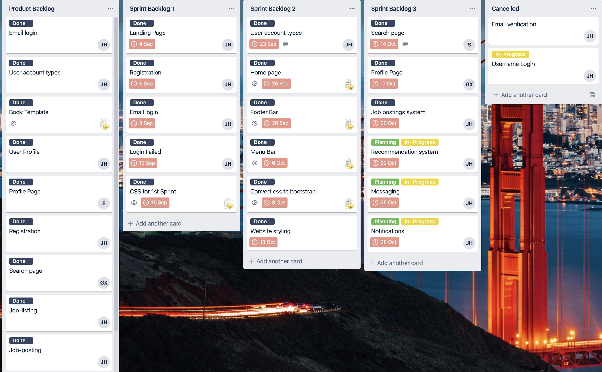

# Daily Scrum Meeting

## Introduction

That teammates get together and do stand-up is called Daily Scrum Meeting. CCJS team uses the Daily Scrum Meeting to track everyone’s progress and what needs to be done for the next step. Teammates got a chance to turn to other teammates during Daily Scrum Meeting as well.

## Team Members Introduction

|  |  |
| --- | --- |
| Name | Initial |
| Jarod Hine | J.H. |
| Siddharth Parmar | S.P. |
| Chengcheng Xiong | C.X. |
| Peng Cheng | P.C. |

## Stand-ups Meeting Record for Sprint 1

Team name: CCJS

Meeting 1

Purpose of Daily Set up:

The purpose of daily set up for this meeting is creating the Email login, user account type, body template, user profile, profile page, registration, search page, job-posting, recommendation system, messaging and notifications for our website.

Date of Meeting: 23 September 2019

Start Time: 13:00 End Time: 15:00

Duration: 2hours

Participants of daily standup:

|  |  |
| --- | --- |
| Initial | Scrum Role |
| J.H. | Scrum Master |
| S.P. | Development Team |
| C.X. | Development Team |
| P.C. | Product Owner |

Members absent: none

Minutes were taken by C.X

Agenda of the meeting:

The plan for this meeting is to create a website that is followed by our tasks which is based on our daily setup, to create a slack group for group members to communicate after the meeting.

The difficulties that we had was uses of Django language to write web pages, it is a new language for all of the team members. So, we had to learn how to use the jungle first and set it up on our laptops and set up the GitHub and the website on the server. we tried to figure out the formatting of each page because there was an issue we tried to use HTML to apply to Django, and it did not work.

Guideline for Daily Standup Meeting:

1. the daily standup meeting should be held in a fixed location, at a fixed time. members should arrive on time and not leave early unless there is an emergency. the advantage of doing this is to keep a good habit for making teamwork more efficient.
2. the standup meeting is meant to be a fast meeting with a good quality, which means that every task involved in the meeting should not take a long time.
3. every team member should keep update for their work statues, it will be easy for other team members know what is going on if there is a problem that is stopping progressing other members might be able to help.
4. one person to speak about the issue at one time will make the communication more clear and will help the project progress smoothly.
5. each team member should check their own work by using Trello and leave a tag to update the status of their work.

Team name: CCJS

Meeting 2

Purpose of Daily Set up:

The purpose of daily set up for this meeting was for loading page, registration, email login, login fail and CSS for the first sprint for our website.

Date of Meeting: 30 September 2019

Start Time: 12:00 End Time: 14:00

Duration: 2hours

Participants of daily standup:

|  |  |
| --- | --- |
| Initial | Scrum Role |
| J.H. | Development Team |
| S.P. | Development Team |
| C.X. | Product Owner |
| P.C. | Scrum Master |

Members absent: none

Minutes were taken by C.X

Agenda of the meeting:

The plan for the meeting is to continue work on the new tasks that are in the daily set up.

the difficulty was we still trying to figure out the right format for Django due to email login has failed.

Guideline for Daily Standup Meeting:

1. the daily standup meeting should be held in a fixed location, at a fixed time. members should arrive on time and not leave early unless there is an emergency. the advantage of doing this is to keep a good habit for making teamwork more efficient.
2. the standup meeting is meant to be a fast meeting with a good quality, which means that every task involved in the meeting should not take a long time.
3. every team member should keep update for their work statues, it will be easy for other team members know what is going on if there is a problem that is stopping progressing other members might be able to help.
4. one person to speak about the issue at one time will make the communication more clear and will help the project progress smoothly.
5. each team member should check their own work by using Trello and leave a tag to update the status of their work.

## Stand-ups Meeting Record for Sprint 2

Team name: CCJS

Meeting 3

Purpose of Daily Set up:

The purpose of this daily set up for this meeting is based on users account types, the home page, footer bar, menu bar, convert CSS to bootstrap, web styling.

Date of Meeting: 7th October 2019

Start Time: 13:00 End Time: 15:00

Duration: 2hours

Participants of daily standup:

|  |  |
| --- | --- |
| Initial | Scrum Role |
| J.H. | Development Team |
| S.P. | Development Team |
| C.X. | Product Owner |
| P.C. | Scrum Master |

Minutes were taken by C.X

Agenda of the meeting:

The plan for the meeting is to continue work on the new tasks that are in the daily set up.

we have figured out the formatting issue of each page and we use cover CSS to bootstrap.

Guideline for Daily Standup Meeting:

1. the daily standup meeting should be held in a fixed location, at a fixed time. members should arrive on time and not leave early unless there is an emergency. the advantage of doing this is to keep a good habit for making teamwork more efficient.
2. the standup meeting is meant to be a fast meeting with a good quality, which means that every task involved in the meeting should not take a long time.
3. every team member should keep update for their work statues, it will be easy for other team members know what is going on if there is a problem that is stopping progressing other members might be able to help.
4. one person to speak about the issue at one time will make the communication more clear and will help the project progress smoothly.
5. each team member should check their own work by using Trello and leave a tag to update the status of their work.

Team name: CCJS

Meeting 4

Purpose of Daily Set up:

The purpose of this daily set up for this meeting is based on the search page, profile page, job postings system, recommendation system, messaging and notifications.

Date of Meeting: 14th October 2019

Start Time: 10:00 End Time: 12:00

Duration: 2hours

Participants of daily standup:

|  |  |
| --- | --- |
| Initial | Scrum Role |
| J.H. | Development Team |
| P.C. | Development Team |
| C.X. | Product Owner |
| S.P. | Scrum Master |

Minutes were taken by C.X

Agenda of the meeting:

The plan for the meeting is to continue the new tasks on our daily set up.

Guideline for Daily Standup Meeting:

1. the daily standup meeting should be held in a fixed location, at a fixed time. members should arrive on time and not leave early unless there is an emergency. the advantage of doing this is to keep a good habit for making teamwork more efficient.
2. the standup meeting is meant to be a fast meeting with a good quality, which means that every task involved in the meeting should not take a long time.
3. every team member should keep update for their work statues, it will be easy for other team members know what is going on if there is a problem that is stopping progressing other members might be able to help.
4. one person to speak about the issue at one time will make the communication more clear and will help the project progress smoothly.
5. each team member should check their own work by using Trello and leave a tag to update the status of their work.

## Stand-ups Meeting Record for Sprint 3

Team name: CCJS

Meeting 5

Purpose of Daily Set up:

The purpose of this daily set up for this meeting is to cancel email verification and username login.

Date of Meeting: 21st October 2019

Start Time: 12:00 End Time: 14:00

Duration: 2hours

Participants of daily standup:

|  |  |
| --- | --- |
| Initial | Scrum Role |
| J.H. | Development Team |
| C.X. | Development Team |
| S.P. | Product Owner |
| P.C. | Scrum Master |

Members absent: none

Minutes were taken by C.X

Agenda of the meeting:

The plan for the meeting is to decide whether we need to use email verification and username login.

Guideline for Daily Standup Meeting:

1. the daily standup meeting should be held in a fixed location, at a fixed time. members should arrive on time and not leave early unless there is an emergency. the advantage of doing this is to keep a good habit for making teamwork more efficient.
2. the standup meeting is meant to be a fast meeting with a good quality, which means that every task involved in the meeting should not take a long time.
3. every team member should keep update for their work statues, it will be easy for other team members know what is going on if there is a problem that is stopping progressing other members might be able to help.
4. one person to speak about the issue at one time will make the communication more clear and will help the project progress smoothly.
5. each team member should check their own work by using Trello and leave a tag to update the status of their work.

Team name: CCJS

Meeting 6

Purpose of Daily Set up:

The purpose of this daily set up for this meeting is to plan for the assignment 2 report, the report has a content introduction, velocity chart, burn-down charts, development of stories across the product backlog and sprint backlog, scrum boards, daily scrum meeting.

Date of Meeting: 28th October 2019

Start Time: 13:00 End Time: 15:00

Duration: 2hours

Participants of daily standup:

|  |  |
| --- | --- |
| Initial | Scrum Role |
| P.C. | Development Team |
| S.P. | Development Team |
| C.X. | Product Owner |
| J.H. | Scrum Master |

Members absent: none

Minutes were taken by C.X

Agenda of the meeting:

The plan for the meeting is separate parts of the report to each member and set a time to complete it.

Guideline for Daily Standup Meeting:

1. the daily standup meeting should be held in a fixed location, at a fixed time. members should arrive on time and not leave early unless there is an emergency. the advantage of doing this is to keep a good habit of making teamwork more efficient.
2. the standup meeting is meant to be a fast meeting with a good quality, which means that every task involved in the meeting should not take a long time.
3. every team member should keep update for their work statues, it will be easy for other team members to know what is going on if there is a problem that is stopping progressing other members might be able to help.
4. one person to speak about the issue at one time will make the communication more clear and will help the project progress smoothly.
5. each team member should check their own work by using Trello and leave a tag to update the status of their work.

# Sprint Demos

## Introduction

The sprint demo is invaluable for keeping stakeholders up to speed with the progress of product development. It allows them to feedback and discusses with the Product Owner and Scrum team any possible amendments to the Product Backlog which would help to maximize value. Our team will use the Sprint Demo to illustrate the functionalities of our product to the stakeholders.

## Sprint 1 Demo

The reason for the selected story was from user’s demands and this could help to make our website become more user-friendly, and for our first demo is about the registration for users when they entering our website, there will be a function allow users to register an account to log in to the web page. and the content of the page should be clear so that users could easily view pages.

## Sprint 2 Demo

Our second demo demonstrated to users that we allow them to select which user account they are going to register for their purpose of using this website, there is a function after user login to the website will jump straight into the home page, and users could use the navigation bar to view other pages, the footer bar is making easy for users to contact information for the website. the style of the page will let users have a better image of the website.

## Sprint 3 Demo

Our third demo demonstrated to the users with the search page functionality for our website, so they will be able to find what they need, the profile page for user to view the information about themselves on the website. there is also a job posting function allow employers to post job advertisements to other users.

# Sprint Retrospectives

## Introduction

CCJS spent half of the day to do each Sprint Retrospective which provides a chance to inspect our products and create a plan for improvements to be enacted during the next plan.

## Sprint 1 Retrospective

### What went well in the Sprint?

- Our group spent half of the day for 1st sprint retrospective, all four members were present to work on the 2nd project to build the actual login system website. As the CCJS were meeting 1st time for the new project it took time to figure out the things that need to be done for the project.

- CCJS was willing to do better than the 1st project, we got the adequate mark because of the mistake which we thought won’t affect our mark but got deducted. So CCJS was pretty motivated to get more marks to cover up for the 1st one.

- CCJS decided to make the login system with Django which was hard but group members shared the tutorials for the Django so every member can contribute.

- Django was the main skill that was required for the project as and pretty difficult as it was new for the CCJS member, we didn’t have any knowledge about Django. It took all the member a while to figure out the Django, we looked online show some tutorials.

- In our team, everyone was willing to contribute and help each other to make the project. I think there was no argument regarding members not doing work in the team which I think was the strongest point.

- Team leader Jarod helped the CCJS in Django while Percy helped to set up the GitHub and the website on the server, so every member can look at the changes made to the web site and work together.

- The 1st sprint finished with dividing the work and helped each other setting up the base/server to work on.

### What went wrong in the Sprint?

- The Thing which didn’t go as planned was that, during the sprint when the work was divided everyone was comfortable that it would be finished in time but somehow when the work on the project started, there was a lot of confusion in building the web site and took more time and conversation on slack to understand what is the right work to do.

- Personally, when the work was divided at that time, I just looked at the work I need to do and didn’t ask any questions as I was planning to finish at home. But when I started the work on the project, I got confused about what needs to be done, how I have to write HTML code, how to see the latest web site which is done by another group member.

- All the member was pretty responsible as it was the 1st time we were starting the project and had time, so there was no pressure, and all took it lightly.

- I was not aware of it as I had done the web designing subject before so I was confident that it would be easy to code in HTML, but as the platform was different and have to take care of the work of other members, it all didn’t go as planned.

- The good part was that we planned everything in Trello, At the beginning CCJS started filling the Trello to keep track of all the work need to be done so on the 1st sprint the task which was needed to be completed before the 2nd sprint were Landing page, Registration, Email login, Login failed, CSS for the sprint. The task was divided among the member and labelled in the Trello.

### What we had to Learn in the Sprint?

- The CCJS learned from the 1st sprint was to discuss the task at the meeting and should start the task a bit so that the individual gets the idea what needs to be done in the project, and if there is confusion then can discuss with the group.

- The techniques we used to was slack to know what is going on with the project and also we created the server which was accessed by all CCJS members so that everyone sees the work done on the website.

- The communication among the team members went smooth as everything was set up like slack, Trello to know what work needs to be done by the group member.

- To install Django and Python didn’t go smooth as a member had MacBook which took a while to understand how to install. Setting up the local server to go online for checking work was complicated as at 1st I didn’t understand how to see what is on the website.

### What should we do differently in the next Sprint?

- The next we decided to focus the strength of an individual to utilize what they good at, so CCJS member divided the work according to the strength, Jarod was doing the Django, Percy managed the tracking of the work, I and Gerrard were doing the HTML code. Though every member contributes in every work.

- Communication with the group member, asking a question and to help each other would help to decrease the issue arising.

## Sprint 2 Retrospective

### What went well in the Sprint?

- CCJS conducted the second sprint retrospective which was half of the day, all four members were present during the 2nd sprint. This meeting was focused on the work given to the CCJS member and to look at the HTML and CSS. The pages we needed to do were User account type, Home page, Footer bar, Menu bar, needed to convert CSS to bootstrap and website styling.

- The motivation behind this sprint was the completion of the work given and to finish the rest of it before the due date. Members were excited to see how the website is going to work and the things members would learn.

- As CCJS wanted to successfully run the project but it was not about completion, it was about the challenges we face and learned which indirectly lead us close to completion of the project day by day.

- Django was confusing for the members and without learning that no one can move forward. So, Jarod the team leader shared the ideas and tutorials which he found useful to learn the basics.

- CCJS understands their members and does the things which were in favourable to every member for example to select the place to meet, the work members are comfortable to do and help if needed even not around.

- At last, CCJS members contributed and shared the work they have done, everyone suggested their idea about the work to improve the project. No was offended at the suggestion but was ready to improve.

### What went wrong in the Sprint?

- CCJS was focusing on the CSS and HTML for the project and was going to implement the Django to make the future easier and reduce the redundancy. CCJS wanted to make the Website look professional.

- Configuring the SQLite database took more time than expected, there was a lot of trial and error finding the right setup for the user’s authorization data There was a lot of time wasted converting from standard HTML to Django template format was still confused with Django which lead in the delay in the project. For me, I was confused with the CSS as I did write the HTML code for the page, but the CSS and the styling were different from the group.

- I was aware that it is going wrong as my page was totally different than the page of the website.

- I understand that it was not the right way to do it and I started to ask the member about my confusion, and I understood the work I needed to change but still went wrong.

- CCJS used the bootstrap later for consistency and to make the website look professional.

### What we had to Learn in the Sprint?

- Sprint was arranged on slack and the date and time were selected according to the preference of all the members.

- The techniques were useful was the use of the bootstrap to make the work easy and done in very little time.

- The techniques to use CSS was not useful.

- The use of bootstrap and the general styling went very smooth as team members didn’t have to worry about the design just need to write the HTML code.

- The use of Django was still complicated was not going as planned.

- It helped us to understand the use of Django and bootstrap though everything was good with bootstrap with Django, we still need to learn it. So in the next sprint, everyone wanted to learn the Django and implemented it in the project.

### What should we do differently in the next Sprint?

- Till now everyone was able to brush up the HTML code and little bit of Django, so the project was divided accordingly.

- To prepare and let all the group members know about how the website would work as it was confusing when the website was looking different.

- The project would be finished in time if all the things in this sprint would be obeyed by the team.

## Sprint 3 Retrospective

### What went well in the Sprint?

- CCJS member completed the website’s all the pages and the only thing remaining was to make the pages function. To add functionality and add a database to save the job listing data. CCJS needed to add functionality on the Search page, profile page, job posting system, Recommendation system, messaging, notification.

- As all the project work was done and the only remaining part was functionality and adding a database, CCJS were very excited and motivated to give the last touch and finish the work to see the final product.

- As the skill which contributed a lot was Django as now everyone was knowing a bit about the Django which helped us to add Functionality.

- I was able to contribute mostly to HTML code and also bit added functionality in the profile page which was given to me.

- Jarod’s good knowledge about Django, Percy’s management about the team, Gerrard’s work esteem to make it happen and my contribution to work make the website happen.

- At this time, we were about to achieve the completion of the project but because of Django and SQLite we were a little behind but somehow the CCJS make it possible on time to give a presentation about the website.

### What went wrong in the Sprint?

- The thing that went wrong was the testing of the demo.

- I personally didn’t show the final product and was dependent on the group members.

- CCJS is responsible for the demo not going as planned as everything was at the last moment and we just ran the final product only one time. So, on the day it didn’t go as planned.

- No was aware of the things going wrong as on the testing day all the pages were working but in the demo, it went wrong.

- How the page was not working was not known by anyone at that point in time so I was not able to fix it.

- The product except for the job posting page everything was working perfectly.

### What did we learn in the Sprint?

### 

- At last, we learned the importance of the sprint as our demo went wrong and Jason told us that all problems should be solved in the sprint and that what sprint is for.

- CCJS were ready to present the product to Jason, all the functionality was working but at last, the demo didn’t work. It was the job posting page that didn’t go as planned.

- Due to each member using their own computer, sometimes when downloading from GitHub the files would be out of sync from the latest, an HTML file was slightly older than it should have been breaking the link, however, the functionality was still accessible by manually entering the URL and also there was some problem in database.

- The techniques were to try the product several times before making the final presentation and the product can go wrong in many ways but one can solve it before the final date.

- The HTML coding of the product went well also the final product demonstration was smooth during the sprint.

- The presentation didn’t go as planned as the job posting page was unable to load.

- The use of a database to store the job posting list was complicated and that is one of the reasons that the website not working.

- As this was the last sprint so there is no next sprint but CCJS learned that in future projects should be tested well enough that even if goes wrong one can solve the problem.

### What should we do differently in the next Sprint?

* To test the product and not depend on the last moment also all the member should contribute on the demonstration of the project and at least test individually so if the product would go through enough test to be good enough to present

# **Product Increments**

## **First Increment:**

For our first increment, we focused on preparing the user accounts and authorization system. We replaced the default user database model leftover from our pilot study with our own custom model. This allowed us to use an email address as a primary identifier in the system. During this increment, we also added in basic CSS styling to increase the visual clarity and ease of navigation.

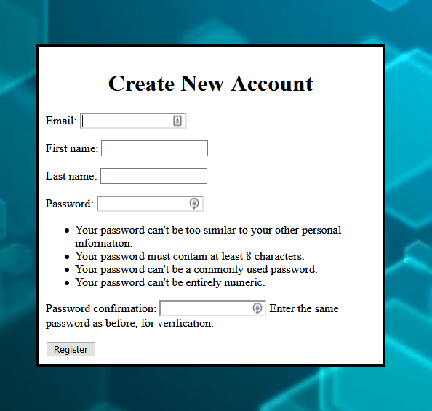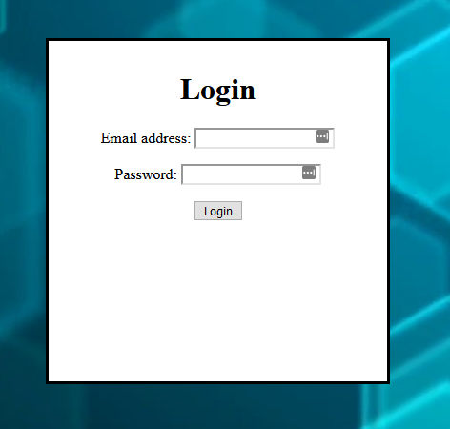

## **Second Increment:**

The focus for the second increment was the HTML and CSS. We wanted the website to look professional and at least somewhat consistent with the JCUs website. We converted the previous HTML into Django’s custom format to make it easier for future development and reduce redundancy. For the CSS we used the web-based tool Bootstrap. Additionally, we updated our custom user model to support 3 different types of accounts for future functions we had planned.

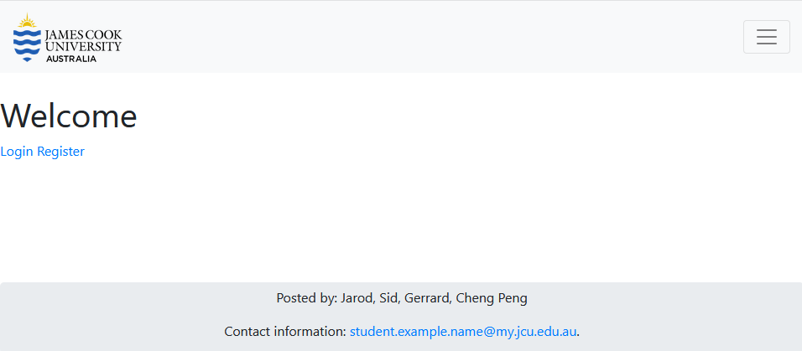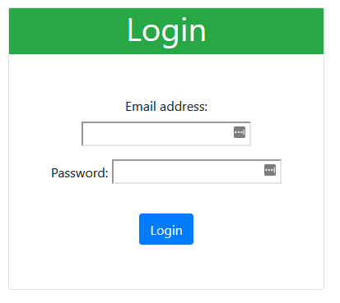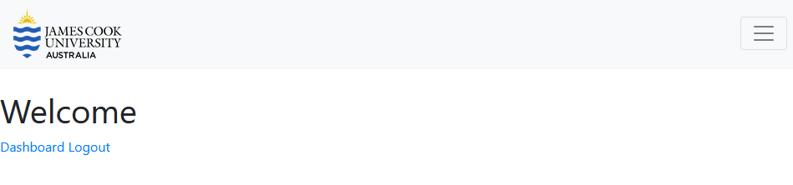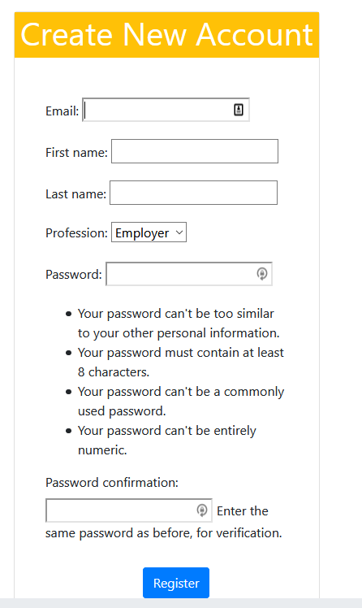

## **Third Increment:**

Finally, for our third increment, we wanted to focus our efforts on making a functional job listing system. We implemented a new model in our database to store the job listing data. The job listings were visible on the home page, clicking the title of a listing will take the user to a new page containing further details. Each job listing consisted of an author, date, title, description, and requirements. Employer users were able to create their own job listing to be viewed on the home page by all other users. Additionally, we added a profile page for users to view their own account information and two search pages that held no functionality at this time.

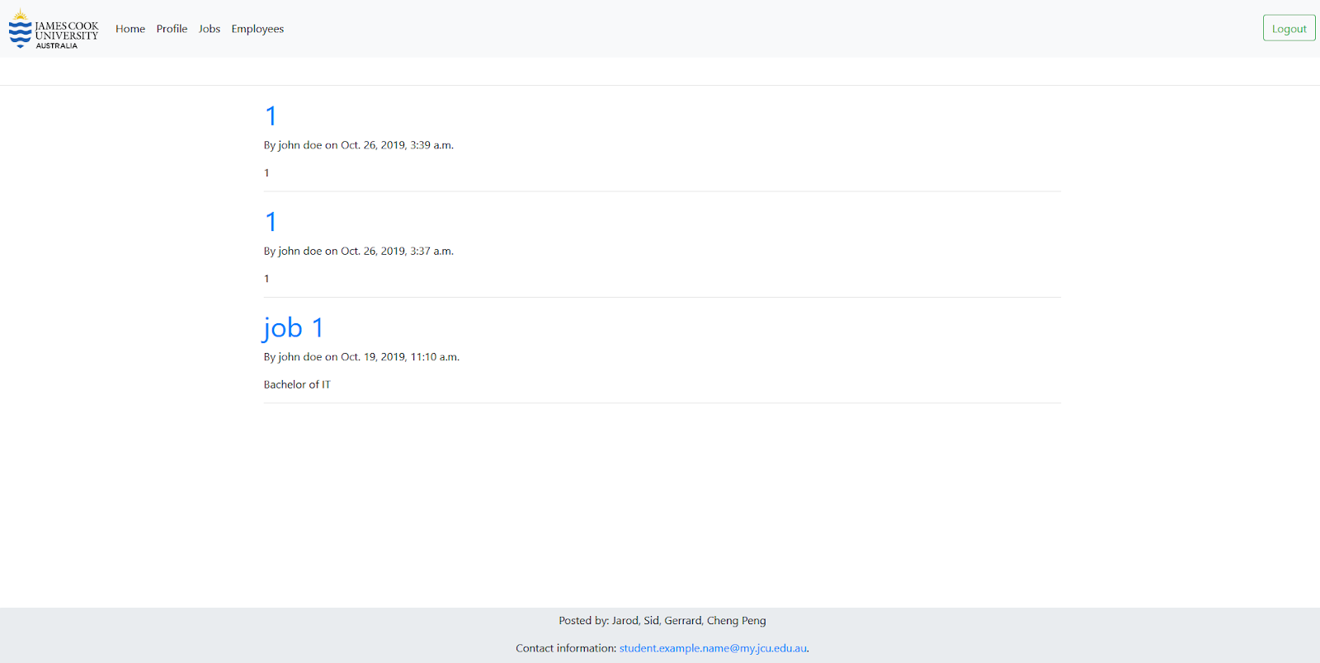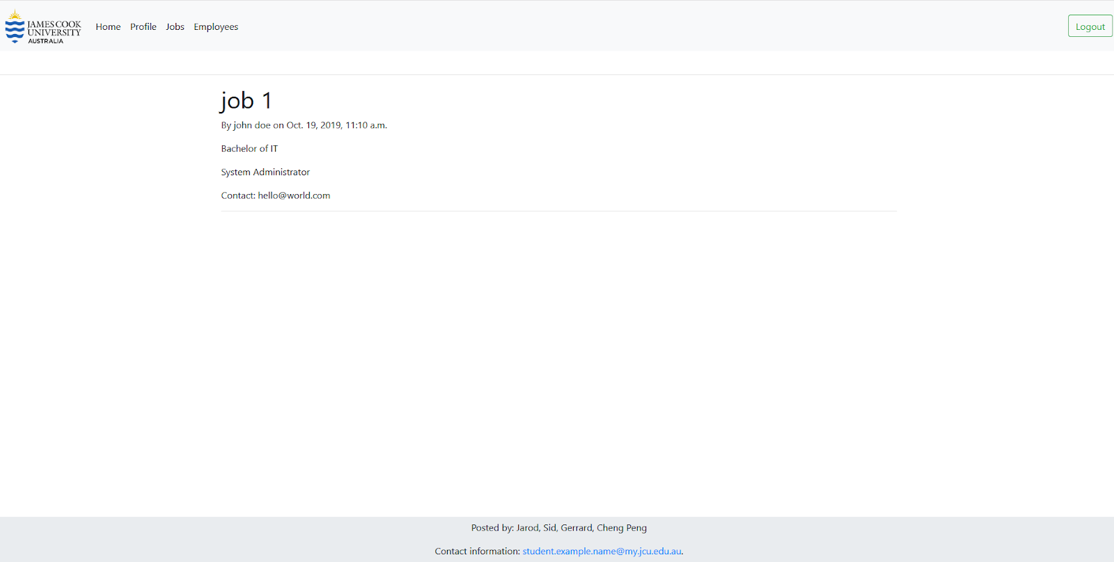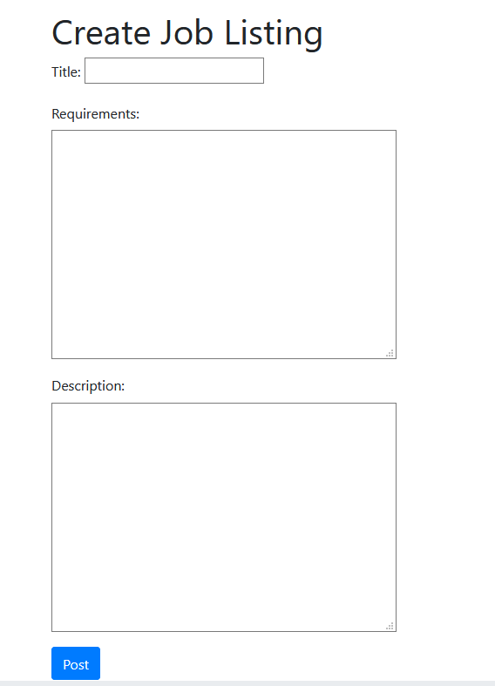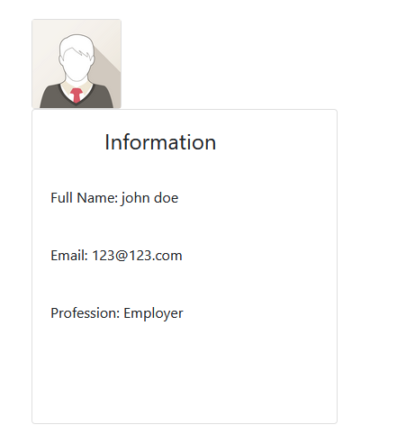

# 

# Conclusion

Though these three Sprints, all of our group members have had a good command of Scrum. From the first iteration to the third iteration, under the guidance of product backlog, our product improves as time goes by. We used the velocity chart to do a prediction for our speed of doing Sprint. Burn-Down Charts are used to track the remaining of our tasks. In each stand-up meeting, we helped each other, improved the quality of the product, solved spikes together and reflected ourselves. Finally, we’ve got Demo to be practical to use. Although our product is not perfect, it’s believed that having gone through another sprint, the product will be satisfactory enough.